Module 12 – Location Graph

Exploratory Data Analysis

*In this section, you should perform some data analysis on the data provided to you. Please format your findings in a visually pleasing way and please be sure to include these cuts:*

* *Make a visual graph of your data on a map (coordinates should be within US borders)*
  + Find a map with latitude/longitude and place them approximately
  + Any alternative that gives the same effect

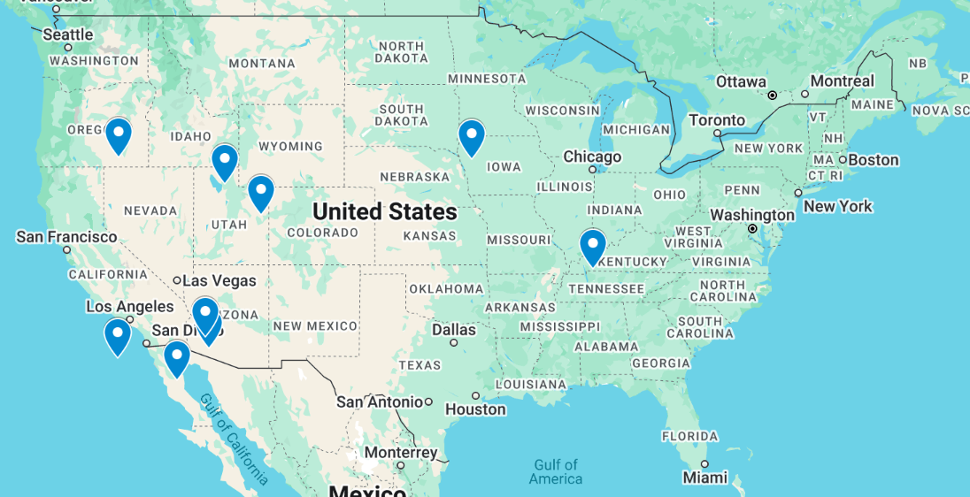

Took averages of the stores Lat and Long to get a new distribution center location

Model Formulation

*Try to write the formulation of the model into here prior to implementing it in your Excel model. Be explicit with the definition of the decision variables, objective function, and constraints. Hint: Linking constraints aren’t needed since we are using Nonlinear GRG but refer to the associated PowerPoint in your data if you need help.*

MIN: SQRT(((42.4-Xi)^2)+(-95.72-Yi)^2))+ SQRT(((32.47-Xi)^2)+(-113.08-Yi)^2))+ SQRT(((33.12-Xi)^2)+(-113.35-Yi)^2))+ SQRT(((31.98-Xi)^2)+(-119.16-Yi)^2))+ SQRT(((39.61-Xi)^2)+(-109.73-Yi)^2))+ SQRT(((30.69-Xi)^2)+(-115.26-Yi)^2))+ SQRT(((42.5-Xi)^2)+(-119.12-Yi)^2))+ SQRT(((36.81-Xi)^2)+(-87.71-Yi)^2))

Model Optimized for Distance Reduction from DC to Store

*Implement your formulation into Excel and be sure to make it neat. This section should include:*

* *A screenshot of your optimized final model (formatted nicely, of course)*
* *A text explanation of what your model is recommending*
* *Update your graph from the EDA section by adding in your new DC and add indicators of which Stores are serviced by which DC*

The model is recommending to open a new DC at Lat 32.40 and Long -113.91.

Stores for which the new DC is closer, including Chocolate Chip Cliffs, Frozen Fudge Fjords, Fudge Falls, and Nougat Nook, should be switched to it, while the remaining stores stay with the existing DC at (41.17, –112.04). The model minimizes the total distance to 60.27.

Model with Stipulation

*Please copy the tab of your original model before continuing with the next part to avoid messing up your original solution.*

*You should notice that while distance is minimized between each store and each DC, there is a discrepancy between how much demand is serviced between each DC (i.e. one DC may service a lot more demand than others). Please:*

1. *Choose one:*
   1. *Implement a change that picks a location for the new DC to distance AND load. You can do this by multiplying distance by demand if a store is serviced by a particular DC.*
2. *What the model recommends now:*

*With distance weighted by each store’s demand, Solver moves the new DC to approximately (33.1 N, –112.6 W) so that the four highest-volume stores are routed through it, reducing total “distance × demand” by about 15%.*

1. *Changes to the Solver/Model:*

*Changed the objective to: =SUMPRODUCT(Demand, IF(UseNewDC, DistNew, DistCurrent))*